Drug Addiction

Specification document

Name: Michael Harrington
ID: C00296932
Supervisor: CM

Table Of Contents

Date: 22/1/2026 2
Use case diagram: (Functional Requirements) 2
Date: 28/1/26 3
Use Cases: 3
GUI Mock-Ups: 7
Testable Non-Functional Requirements: 9

Date: 22/1/2026

Use case diagram: (Functional Requirements)

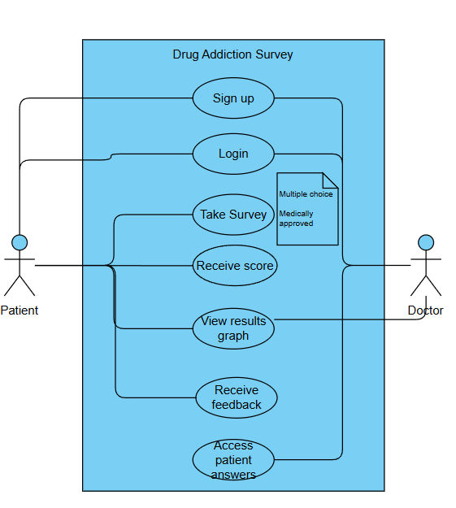

Date: 28/1/26

Use Cases:

Name | Sign Up
Description | The Doctor and Patient must first sign up to use the website
Actors | Patient, Doctor
Main Course | - Patient first opens up the website  - Patient then clicks sign up  - They then choose whether they are signing up as a doctor or patient  - If they are a doctor they must provide identification to prove they are a registered doctor.

Name | Take Survey
Description | The Patient will be able to take a survey for a specific drug addiction and answer a set of questions that follow GDPR.
Actors | Patient
Main Course | - The patient clicks the take survey button.  - They are taken to a separate page where they can begin the survey.

Name | Login
Description | The Patient will be able to login to take the survey as well as the doctor to view the raw answers from the patients.
Actors | Patient, Doctor
Main Course | 1.Patient or doctor first creates an account  2.Patient or doctor are then prompted to login using the details they entered for the sign-up.

Name | Receive Score
Description | The Patient will be able to take a survey for a specific drug addiction and answer a set of questions that follow GDPR.
Actors | Patient
Main Course | - Patient must first be logged in  - Patient takes the survey and completes all required questions  - Patients can then view the score of their completed survey.

Name | View Graph of Results
Description | The patient or doctor is able to view a graph based on the results of the patient's surveys.
Actors | Patient, Doctor
Main Course | - Patient or doctor must be logged in  - Patient must access their profile storing the information of past survey results  - Doctors must view the database of all patients and choose one to view a survey of.

Name | Access patients raw answers
Description | The Doctor can access the Raw answers from the patients that took the survey
Actors | Doctor
Main Course | - Doctor must first be logged in  - The doctor then must access the database off all patients that have taken the survey  - Finally the doctor chooses a patient to view the raw results of.

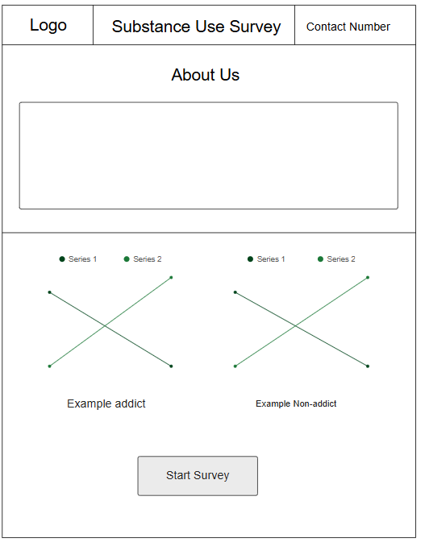

GUI Mock-Ups:
Main menu:

Login/Sign up:

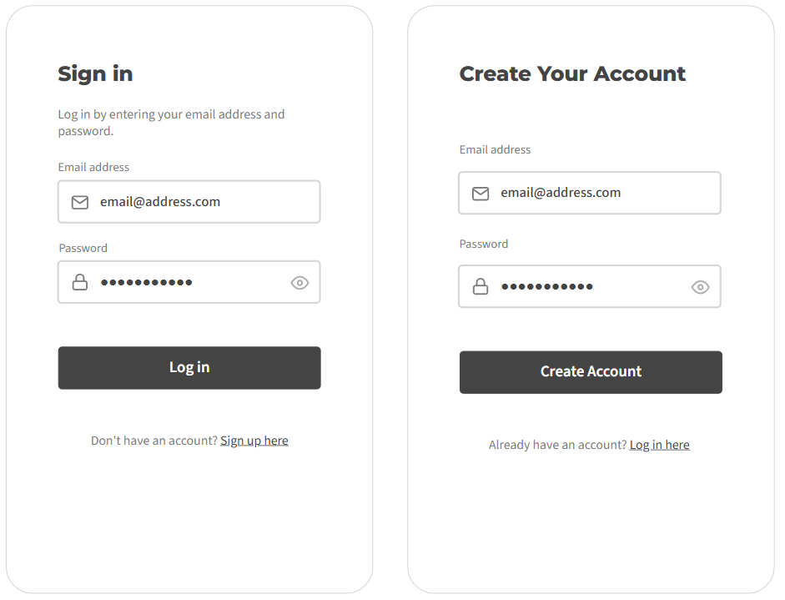

Survey Screen:
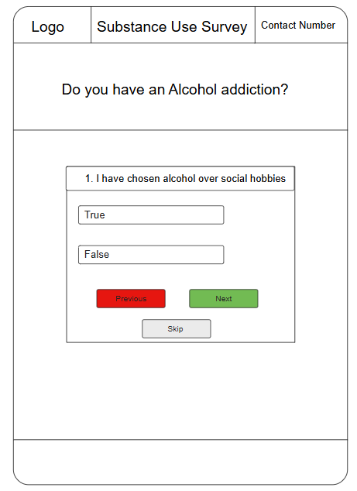

Testable Non-Functional Requirements:

A Clear Privacy Policy:
The website will display a privacy policy page that explains what data is collected.
Verification: Manual Inspection

GDPR (Non-Hackable):
Website will comply with GDPR requirements

Verification: Legal compliance audit

Desktop, mobile and tablet friendly:
The website will be fully usable on all three devices

Verification: Cross-device testing

Results are not a diagnosis:
Big disclaimer stating that survey results are not a medical diagnosis on the main and survey pages

Verification: UI inspection

No tracking data without consent:
The website will not store any tracking cookies until the Patient has provided consent

Verification: Cookie audit

